A Minor Project Proposal on
Online Travel Marketplace
Submitted in partial fulfillment of the requirements for the degree of
Bachelor of Engineering in Software Engineering at Pokhara University

By
Aayush Parajuli
Prakriya Parajuli
Sworup Khadka


Department of Research and Development
GANDAKI COLLEGE OF ENGINEERING AND SCIENCE
Lamachaur, Kaski, Nepal
(October, 2023)

A Minor Project Proposal on
Online Travel Marketplace
Submitted in partial fulfillment of the requirements for the degree of
Bachelor of Engineering in Software Engineering at Pokhara University

By
Aayush Parajuli
Prakriya Parajuli
Sworup Khadka

Supervisor
Dr. Bidur Devkota
Department of Research and Development
GANDAKI COLLEGE OF ENGINEERING AND SCIENCE
Lamachaur, Kaski, Nepal
(October, 2023)

APPROVAL CERTIFICATE
This project entitled "Online Travel Marketplace" prepared and submitted by "Aayush Parajuli, Prakriya Parajuli & Sworup Khadka" under the supervision of "Dr. Bidur Devkota " in partial fulfillment of the requirements for the Degree of Bachelor of Engineering in Software Engineering has been examined and is recommended for approval and acceptance.

Date of Evaluation: October 12, 2023

……………………………………
Dr. Bidur Devkota
(Project Supervisor)

…………………………………
Er. Rajendra Bahadur Thapa
Project Head
Research Management Committee
Gandaki College of Engineering and Science

ABSTRACT
The Online Travel Marketplace project aims to transform the travel industry in Nepal by empowering smaller and medium-sized travel businesses and enhancing the travel experiences for adventure seekers and cultural enthusiasts. The project will enhance the travel experiences of explorers visiting Nepal by providing an intuitive web-based platform that simplifies and streamlines the booking of travel experiences. Our web-based platform will curate authentic local experiences, offering transparent pricing and a streamlined booking process. By democratizing access to the online booking space, we will empower businesses and provide travelers with a wider range of unique and enriching experiences.

TABLE OF CONTENTS
APPROVAL CERTIFICATE iii
ABSTRACT iv
Table of Figures vii
Index of Tables viii
Chapter 1 1
INTRODUCTION 1
1.1 Background 1
1.2 Problem Statement 1
1.3 Objectives 1
1.4 Implications 2
Chapter 2 3
LITERATURE REVIEW 3
Chapter 3 5
TOOLS AND METHODOLOGY 5
3.1 Required Tools 5
3.2 Methodology 5
Bibliography 7

Table of Figures
Figure 1: Waterfall Model 5
Figure 2: Use Case Diagram 6

Index of Tables

Chapter 1

INTRODUCTION

1.1 Background
The tourism industry is a vital contributor to Nepal's economy, generating employment and showcasing the country's stunning natural beauty and rich cultural heritage. However, the current travel booking landscape faces several challenges, hindering its growth and impacting both travelers and local businesses. Smaller travel businesses struggle to compete with larger corporations due to their limited online presence. While, travelers often encounter confusing and inaccurate information regarding prices, inclusions, local regulations, and travel experiences. The Online Travel Marketplace (OTM) is designed to address these critical challenges and revolutionize the online travel booking landscape in Nepal.

1.2 Problem Statement
Despite possessing unique insights and local expertise, small and medium-sized travel businesses in Nepal struggle to compete effectively in the online sphere. Limited financial resources restrict their ability to develop robust online presences and reach potential customers, creating an uneven playing field dominated by larger corporations. Travelers venturing to Nepal often encounter a frustrating lack of transparency in the booking process. Opaque pricing, unclear inclusions, and unreliable information about local regulations and travel experiences lead to confusion, erode trust, and ultimately diminish the quality of the travel experience. The combined effect of these challenges creates a disadvantageous environment for both travelers and local businesses in Nepal's tourism industry.

1.3 Objectives
The main objective is to establish a robust online travel marketplace as a web application to empower smaller and medium-sized travel businesses (SMEs) in Nepal. This platform aims to address the current challenges faced by both travelers and local businesses in the tourism industry.
The specific objectives of this project are as follows:
- Make online travel booking accessible to smaller and medium-sized travel businesses in Nepal.
- Create a user-friendly platform that simplifies the process of planning and booking travel experiences in Nepal.
- Establish a level playing field for travel businesses of all sizes by providing equal opportunities and access within the marketplace.
- Ensure transparency and trust in the booking process by providing clear and accurate information about prices, inclusions, local regulations, and traveler reviews.

1.4 Implications
The Online Travel Marketplace project carries profound implications for Nepal's travel industry and its stakeholders. By democratizing the online travel booking space, it opens doors for local businesses, particularly small and medium-sized enterprises to compete on a level playing field, fostering their growth. This empowerment extends to travelers who will gain access to a curated selection of travel experiences, offering them more fulfilling and personalized journeys allowing them to explore Nepal in a more meaningful and informed way. . The project also addresses long-standing issues of transparency and trust within Nepal's travel industry. By eliminating opacity in the booking process, it seeks to build trust between travelers and service providers

Chapter 2

LITERATURE REVIEW
In the dynamic realm of the travel industry, we derive valuable insights from influential online travel booking platforms such as Booking.com, MakeMyTrip & eSewa. These industry giants offer a plethora of travel products and services, constituting a foundation for Online Travel Marketplace' venture. However, it's crucial to recognize their strengths and the areas where innovation is imperative.
Booking.com is a global stalwart established in 1996, commands an extensive portfolio of travel products, encompassing over 28 million accommodations worldwide. Nonetheless, Booking.com's registration and listing procedures may pose challenges for smaller Nepali travel businesses. This platform also struggles to cater to the unique needs and preferences of travelers exploring Nepal.
MakeMyTrip is India's leading online travel booking platform since 2000, offers a comprehensive array of services, from flights and hotels to tours and car rentals. Similarly, smaller travel businesses in Nepal encounter hurdles during the registration and listing process on MakeMyTrip. Adapting to Nepal's distinctive local travel landscape can present ongoing challenges.
eSewa, a pioneer in the Nepali digital payments landscape, established in 2009, has become synonymous with convenience and security. Its vast network of partnered businesses, including airlines, hotels, and tour operators, allows users to seamlessly book and pay for travel experiences online. However, it's essential to acknowledge that eSewa does not operate as an open marketplace, primarily offering its trekking and tour services. limiting the platform's diversity of offerings and hindering smaller local enterprises.
The reviewed models, Booking.com and MakeMyTrip, falter in providing the distinct and localized experiences that travelers in Nepal desire, leaving a void in the market. Additionally, they pose significant barriers for small and medium-sized Nepalese travel businesses. TrekkingDude's lack of an open marketplace further restricts the range of available travel experiences. In contrast, Online Travel Marketplace emerges as a transformative solution to bridge these gaps and meet the unique demands of Nepal's travelers and businesses.

Chapter 3

TOOLS AND METHODOLOGY

3.1 Required Tools
To develop the application, we will require various tools essential for the project. Our project will use the following tools:
- JavaScript: For Client side scripting.
- HTML and CSS: For Frontend design.
- Draw.io: For diagramming software.
- Php:
- MYSQL database: For managing system databases.
- Libre Office Writer: For writing proposals and reports.
- Figma: For UI/UX design.

3.2 Methodology
Every software development methodology approach acts as a basis for applying specific frameworks to develop and maintain software. Several software development approaches have been used since the origin of information technology. The online travel marketplace web application system implements the Waterfall model. It is compatible with the size of our project and suited for the available time frame.
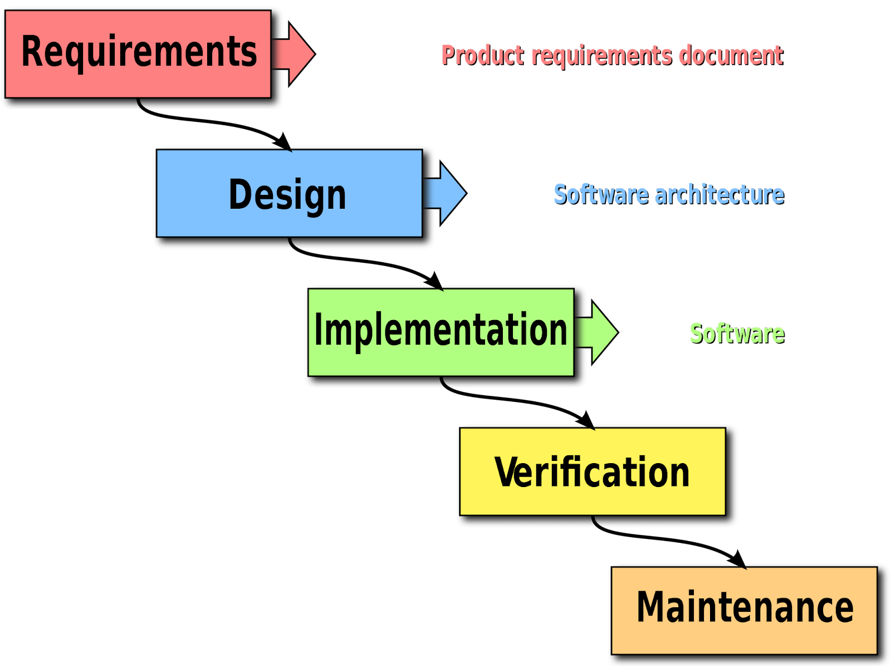Figure 1: Waterfall Model

3.3 UML Diagrams
3.3.1 Use Case Diagram
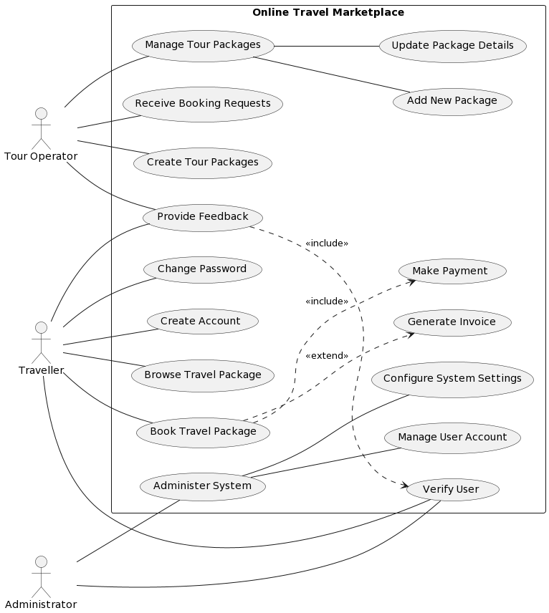Figure 2: Use Case Diagram

A use case diagram is a way of visualizing the requirements and functionalities of a system. It shows the actors (users or roles) and the use cases (actions or goals) they can perform in the system. In this diagram, the system is an online travel marketplace that allows tour operators, travelers, and administrators to interact with each other. The diagram shows what each actor can do in the system, such as managing, browsing, booking, and providing feedback on travel packages, as well as administering user accounts and system settings. The diagram also shows the relationships between the use cases, such as inclusion, extension, and generalization.

Bibliography

